
- Home
- About Us
- Products & Services
- How We Work
- Contact Us
- Download

Request for Quotation
Get Demo



Pakiza Technovation Limited
a sister concern of Pakiza Group
With a mission to deliver Excellence, through Innovation in designing solutions, implementing those in an innovative way using the right technologies. PTVL is the newest concern of renowned Pakiza Group, the standard of excellence in all its business sectors. PTVL always love to optimize, not to be lowest price, its solution to meet its client’s requirement & thus ensure value for money. Ensuring high quality in both product & service, PTVL wants to give its client’s a great experience & to be reliable and first choice of its kind.
Request for Quation

Mission

To deliver Excellence through Innovation Using Technology.

Vision

To be the technology partner of choice for forward-looking customers by collaboratively transforming technology into business advantage.

Values

PTVL always love to optimize, not to be lowest in price, its solution to meet its client’s requirement and thus ensure value for money As the visibility of ICT projects are result driven, it ensures the promised result and the project outcome becomes visible.

Quality Policy

Our goal is to be one of the recognized organizations for IT hardware solutions and Software development in the country. To achieve this goal, we ensure - IT Hardware and solution business, delivery of Bespoke Software (Design, Coding and Testing), and the follow-on customer service is an essential part of the quality process. - All employees receive training to ensure awareness and understanding of quality and its impact on customer service. - The leadership team are responsible for ensuring that the quality objectives, and commitments to satisfy any applicable requirements continually improve the quality management system.

We believe in
Pakiza Technovation Limited believes in delivering Excellence through Innovation using Technology and ensuring high Satisfaction level of its clients.
Previous


High Quality
Ensuring high quality in both product and service pakiza Technovation Limited wants to give its clients a great experience and to be reliable and first choice of its kind.


Right to know
We believe that clients have the right to know in and outs of every elements of a solution or service or product and we do ensure.


Service Excellence
Pakiza Technovation Limited team is hungry to generate Innovative ideas, implement those using right technologies and ensure Excellence is delivered.


Customer Satisfaction
Pakiza Technovation Limited team is keen to understand its clients expectations and thrives to surpass expectations through expertise and achieve loyalty.


Value For money
Pakiza Technovation Limited always loves to optimize, not to be lowest in price, its solution to meet its clients requirement and thus ensure vaue for money.


Visibility
Visibility of ICT projects are result oriented. Hence Pakiza Technovation Limited ensures the desired result and makes it visible by showing exact result that is promised.

High Quality
Ensuring high quality in both product and service pakiza Technovation Limited wants to give its clients a great experience and to be reliable and first choice of its kind.

Right to know
We believe that clients have the right to know in and outs of every elements of a solution or service or product and we do ensure.

Service Excellence
Pakiza Technovation Limited team is hungry to generate Innovative ideas, implement those using right technologies and ensure Excellence is delivered.

Customer Satisfaction
Pakiza Technovation Limited team is keen to understand its clients expectations and thrives to surpass expectations through expertise and achieve loyalty.

Value For money
Pakiza Technovation Limited always loves to optimize, not to be lowest in price, its solution to meet its clients requirement and thus ensure vaue for money.

Visibility
Visibility of ICT projects are result oriented. Hence Pakiza Technovation Limited ensures the desired result and makes it visible by showing exact result that is promised.

High Quality
Ensuring high quality in both product and service pakiza Technovation Limited wants to give its clients a great experience and to be reliable and first choice of its kind.

Right to know
We believe that clients have the right to know in and outs of every elements of a solution or service or product and we do ensure.

Service Excellence
Pakiza Technovation Limited team is hungry to generate Innovative ideas, implement those using right technologies and ensure Excellence is delivered.
Next
- 1
- 2
- 3
- 4
- 5
- 6
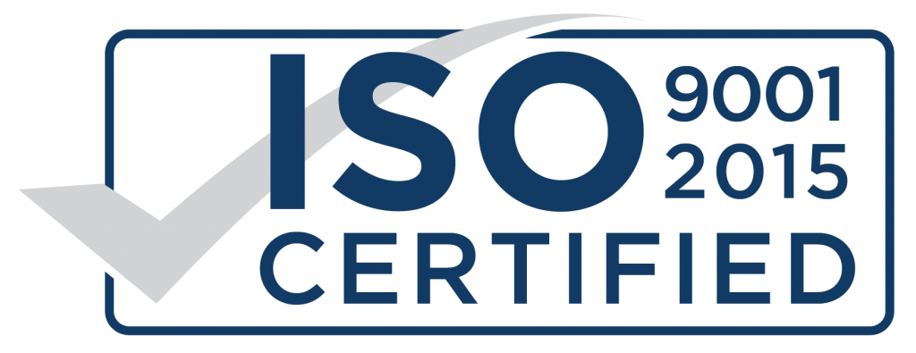

ISO 9001:2015 Certified Company
Our company has been ISO certified for Quality Management Systems since 2009. Pakiza Technovation Limited, PTVL in short is a developed organization and providing quality IT solutions to the different Govt. and Private Organizations and solving their problems of aligning IT with business direction.

OVERVIEW

PTVL by NUMBERS


50+
TEAM MEMBER


200+
NUMBER OF CLIENTS


10+
SOFTWARE & SOLUTION


100+
POSITIVE FEEDBACK


6+
DEPARTMENTS


11+
INDUSTRY EXPERTS

TECHNOLOGY

OUR SKILL MATRIX

Software & Web developement
ASP.NET, PHP, JavaScript, Python, JQuery, Ajax, HTML5, CSS MSSqlServer, Oracle, MySql, Firebase

E-Commerce
PhpCMSl, Woocommerce, PrestaShop, Magento

Mobile application
Flutter, Kotlin, Progressive web application (PWA)

Reports
Google Analytics, Crystal Reports, JReports, WForms


Hardware solution
HP, HPE, CISCO, JUNIPER, F5, FORTINET, SHOPHOS


Manged Service
BreakFix, Monitoring, Help desk, Resource outsourcing



Data center Infra. solution
CommScope, Rosenberger, Online UPS, PAC, EMS, FIRE


Security & Surveillance
HikVision, ZKTEco, Grrrett, Suprema, P A System

With a mission to deliver Excellence, through Innovation in designing solutions, implementing those in an innovative way using the right technologies. Pakiza Technovation Limited is the newest concern of renowned Pakiza Group, the standard of excellence in all its business sectors. Pakiza Technovation Limited always love to optimize, not to be lowest price, its solution to meet its client’s requirement & thus ensure value for money.

Address
Head office : House# 97, Road# 11/A,
Dhanmondi, Dhaka-1209, Bangladesh
+880 9612 811 111
info@pakizatvl.com
Registered office: Khordo Nowpara,Rasulpur Narsingdi (Sadar), Narsingdi-1600, Bangladesh

Get Connected

App privacy and policy


© 2023 Pakiza Technovation Limited

